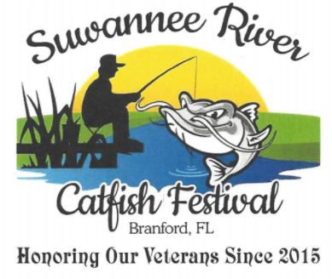

Suwannee River Catfish Festival Scholarship Pageant
Contestant Age Division & Contestant Information
Saturday February 9, 2019 at 6:00 PM
Pageant Director, Diane Walker-Saunders
Phone numbers: PLEASE try my home first at 386 935-1017
or my cell 386 208-9426

THE TEEN & MISS TITLEHOLDER WILL BE GRANTED A SCHOLARSHIP!
The Miss Titleholder will receive a $200.00 Scholarship
The Teen Miss Titleholder will receive a $100.00 Scholarship +++PLUS+++
We will have prize packages for the Miss, Teen & Pre-teen Catagories

AGE DIVISION & CONTESTANT INFO

Toddler Miss Division Girls 2 – 3 Years

Little Miss Division Girls 4 – 7 Years

Pre-Teen Miss Division Girls 7 – 12 Years

Teen Miss Division Girls 13 – 15 Years

Miss Division Girls 16 – 18 Years

If we have only one contestant for any particular age division, this age division will be dropped from the pageant. We must have more than one contestant per division.

The Teen Miss & Miss Divisions will participate in an opening number and contestants will be judged on this category.

SCORING CATEGORIES FOR TODDLER THROUGH PRE TEEN DIVISIONS

Smile 1 – 25 Points Poise in Gown/Party wear 1 – 25 Points
Personality 1 – 25 Points Overall Impression 1 – 25 Points

TOTAL POSSIBLE SCORE – 100 POINTS

SCORING CATEGORIES FOR TEEN & MISS DIVISIONS

Smile 1 – 20 Points Personality 1 – 20 Points

Opening Number 1 – 5 Points Poise in Gown/Party Wear 1 – 25 Points

On-Stage Question 1 – 10 Points Overall Impression 1 – 20 Points

TOTAL POSSIBLE SCORE – 100 POINTS
ALL TITLEHOLDERS (WINNERS) PLEASE BE ADVISED
OF THE FOLLOWING TITLEHOLDER REQUIREMENTS
The titleholders of each division WILL BE REQUIRED to appear at our
Annual Suwannee River Catfish Festival on Saturday, April 13 2019. The Festival is held each year on the Greenway in front of the Branford Shrine Club.
We REQUEST ALL TITLEHOLDERS to ride in various other area parades that we may participate in (River Reunion Parade, BHS Homecoming Parade, Branford & Live Oak Christmas Parades) & other Festival Board Approved parades. LASTLY you are required to participate in our forthcoming Pageant in 2019 to crown your age division winner.
SPECIAL NOTE: If for any reason you are unable to carry out the requirements of your title, you will be asked to step down, forfeit your crown and the first runner-up in your age division will be given your title. IT IS YOUR RESPONSIBILITY TO ADVISE US IF THIS HAPPENS. ++PLUS++ It is your responsibility to GIVE A TIMELY RESPONSE to ALL COMMUNICATIONS from the Pageant Director.
If you have to miss a parade or function, YOU MUST contact the Director immediately. You will be allowed to miss ONLY 2 PARADE(S) AND/OR APPEARANCES/FUNCTIONS.
From the Pageant Director
I hope the above info will provide you with ALL the information you need to prepare for our Pageant and make it stress free for you and a FUN TIME! I am available to speak with you personally and you may contact me at my PRIMARY HOME number at 386 935-1017 or you may leave a message or text me at 386 590-6923.
I sincerely thank each of you and your parents for your participation in our
Annual Suwannee River Catfish Festival Pageant. I pledge I will do my best to make this pageant fun and as fair as is possible.
Sincerely,
Diane Walker-Saunders, Catfish Festival Board Member & Pageant Director

