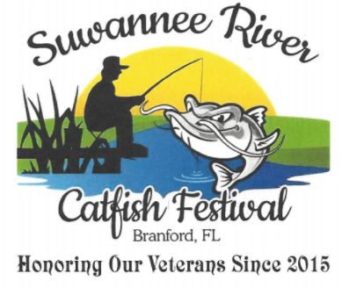

SPONSOR FORM
April 8,2023
Company Name:
Address:
Contact Person:
Phone Number: E-mail:

LEVELS
Grand Daddy Catfish: $1000.00 [3x5 Banner & name on sponsor shirt]
Big Whiskers Catfish: $750.00 [ 2x5 Banner & name on sponsor shirt]
Channel Catfish $500.00 [1x4 Banner & name on sponsor shirt]
Speckled Catfish $250.00 [1x3 Banner & name on sponsor shirt]
Mud Puppy $100.00 [yard sign one color 1]

Please list below the information you would like on your sign:

Sponsorship monies go towards the two Scholarships for the winners of the Suwannee River essay contest and donations to local charities. All sponsor form and money are due by March 8,2023.
CATFISH FESTIVAL REPRESENTATIVE

